Defining the important things from the urgent things

URGENT! No, not really. NO! It’s URGENT! DO IT NOW!

How do you define the importance of to-dos and layout a strategic plan for planning? Join the gruesome twosome in figuring out these details in the Plannerverse.

Nothing we say can be used against us, unless of course, it’s urgent.

If you have ideas for future episodes please send them to steve at philofaxy dot com

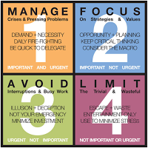
Show Notes (timings approximate)
00:00 - Introductions
01:00 - Prioritising things
01:10 - The Eisenhower quadrant
03:00 - Article on the website - Art of Manliness
03:45 - Demands on our time
07:00 - Your decisions on a daily basis
07:45 - Distinguishing the important and the non-important issues in life
08:30 - Working towards goals
10:00 - Weekly planning
11:15 - Assigning tasks to days
12:30 - Small and permanent habit changes
14:15 - Quadrant four time wasters
15:00 - Breaking down the big tasks/projects to make them acheiveable
17:15 - Assigning priorities to tasks in a paper planner
18:00 - Splitting tasks throughout the year.
19:30 - Delegating tasks
19:50 - Omnifocus
21:00 - Putting tasks in to contexts
22:15 - Bullet Journalling
23:30 - Parallel and consecutive tasks
25:30 - Train yourself from living in quadrant 3 and 4
26:45 - Dive in to a book or listen to our podcasts when you want to have 'time out'
28:00 - Steve's homework for this week!
29:45 - Tip of the week

