Hobonichi's or ringed planners

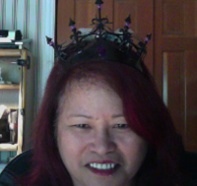
Rings? RINGS?! We don’t need no stinkin’ rings!

Gather round all ye who enjoy the Hobonichi notebook and pay heed as our lovely guest, Theresa Hall, shares with us her inspiration for art and all the advice she has for those who have been thinking about planning in a Hobonichi style planner.

Steve is on special assignment this week.

If you have ideas for future episodes please send them to steve at philofaxy dot com

Show Notes (timings approximate)
00:00 - Introductions
02:00 - Art in ringless planers
02:30 - Why doodle?
04:00 - When did you start?
07:00 - Why a Hobonichi and not a ringed planner
09:00 - What if you are critical of your drawings
10:30 - Planning in a Hobonichi
12:00 - Stickers and washi tape
15:45 - How has your system evolved
19:00 - Digital world
22:00 - Disconnecting from the digital world
24:45 - To do list for the week
26:00 - Why should you use a Hobonichi?
26:45 - Karine's experience of using a Hobonichi

