Guest interview - Ray Blake
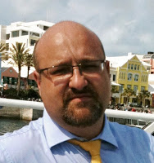
In this episode we welcome Ray Blake who is a major contributor to the planner community in the form of his planner inserts which he does with Steve and the ones he does for travellers notebooks as well.

Ray describes how he uses his Travellers Notebook on a daily basis

If you have ideas for future episodes please send them to steve at philofaxy dot com

Show Notes (timings approximate)
00:00 - Introductions
01:00 - The meeting!
02:40 - Travellers Notebook sizes and their evolution.
07:40 - Cutting notebooks to size (video)
08:00 - Making your own TN inserts
09:15 - What Ray uses for planning
12:30 - The three things, Planner, Todo, Notes
13:45 - Journalling
16:30 - Ray's Journalling Book
17:00 - Pens
20:00 - Carry it, write in it and read it.
23:00 - Best time for ideas
24:00 - Last minute at night notes
26:45 - Notebook archive and database
28:00 - Tip of the week
29:00 - Midori Travellers Resources Facebook Group
30:00 - Always start with plain paper

