Digital devices/services and your analogue planner

The Plannerverse Gods have had mercy on the Gruesome Twosome. We’ve made it to Episode 20!

In this episode we tackle the never ending barrage of digital devices that are constantly demanding our attention. Steve acts as the Ringleader, whipping these devices into byte-size (get it? get it?!) thoughtlets, whilst Karine insists on using them along with our analogue planners.

Tune in to see who wins the logical arguments of letting robots tell us what to do with our lives.

If you have ideas for future episodes please send them to steve at philofaxy dot com

Show Notes (timings approximate)
00:00 - Introductions
01:00 - The progress of technology
03:00 - The division of technology versus analogue
04:00 - Casio Digital Diary

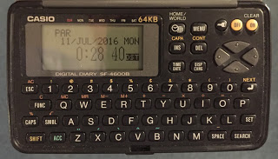

05:00 - Digital supplementing analogue
06:00 - What you use for what.
06:45 - Digital apps for to-do tasks... Steve has a good rant!
09:00 - Time zone changes can catch you out.
11:00 - Why Steve changed from analogue to digital back in the 1990's
13:00 - Sync issues
14:00 - Google Calendar failure!
15:00 - The issue of always having the latest digital device
15:30 - Psion 5mx

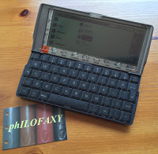

16:00 - The versatility of modern tablet computers...but
18:00 - Cross checking analogue/digital
20:00 - Reserving time to keep yourself up to date
20:45 - Omnifocus
21:00 - Pocket Informant
23:30 - Psion Agenda

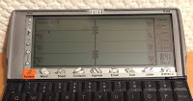

24:00 - Using a standalone none internet connected devices for digital reminders.
25:00 - Having a paper list of your repetitive tasks that you normally use electronic applications
27:00 - Make sure digital backs up your analogue
28:00 - Tip of the week.

